Lim, Francis Raemark L.

Monoso, Jose Miguel

Plot:

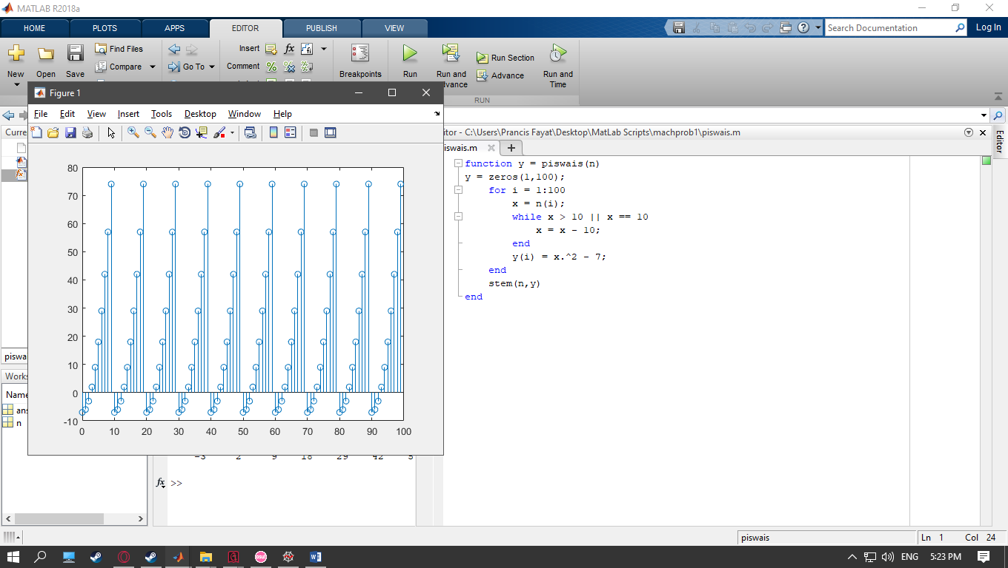

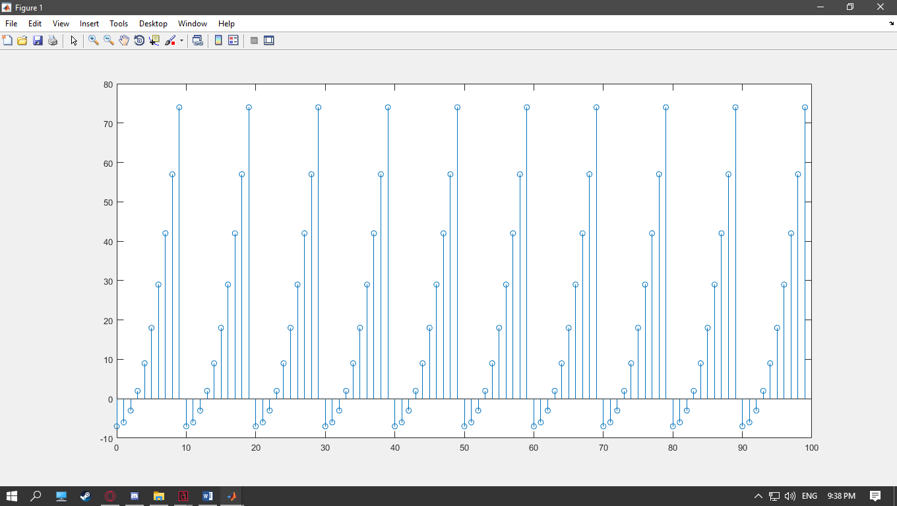

Observations:

At n = 0 to 9, its y values range from -7 to 74, it can be described as an exponential curve with a vertical shift of -7. At n = 10 to 19, its y values are the same to the y values at n = 0 to 9. At n >= 10, n gets decreased by 10 and then and it is inputted into the piecewise function again. If the decreased n is still greater than or equal to 10, it gets decreased by 10 again and is inputted into the function again.